Лабораторная работа 1 ЗК ОДУ

Вариант 16

Задача Коши и точное решение

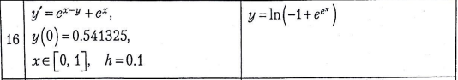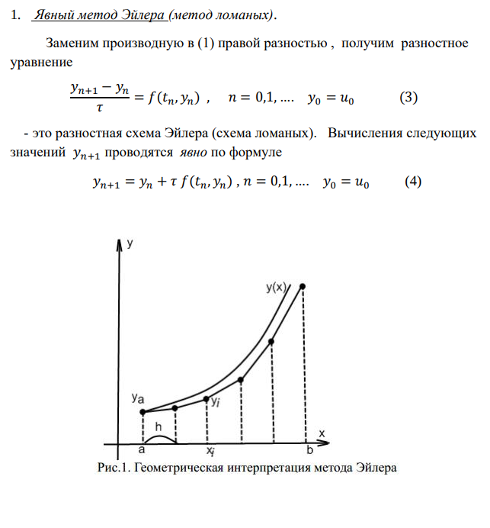

y = [0.541325]

for i in range(1, n):

y.append(y[i-1] + h1\*df(x[i-1], y[i-1]))

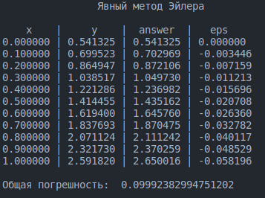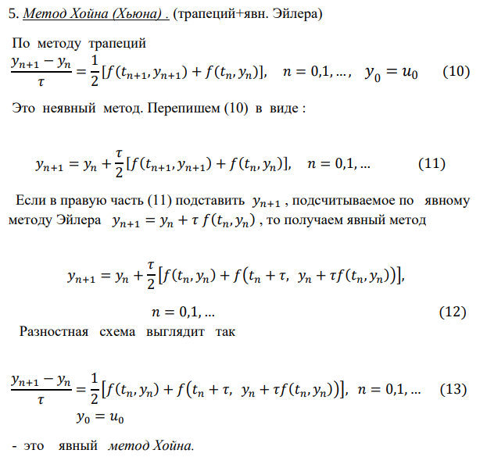

y1 = [0 for i in range (n)]

y1[0] = 0.541325

for i in range(0, n-1):

y1[i+1] = y1[i] + h1/2\*(df(x[i+1],y[i+1]) + df(x[i],y[i]))

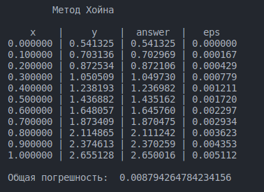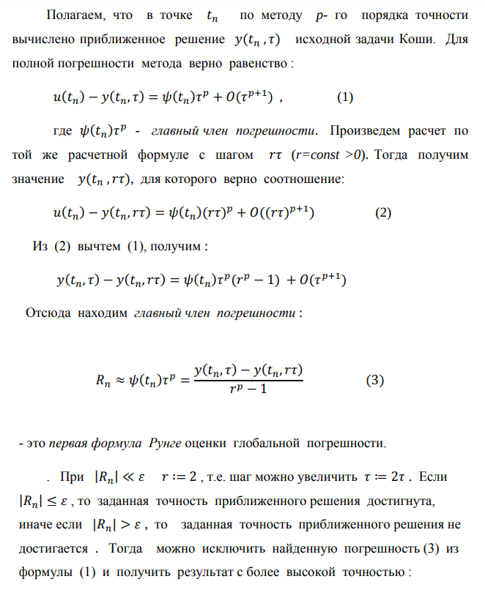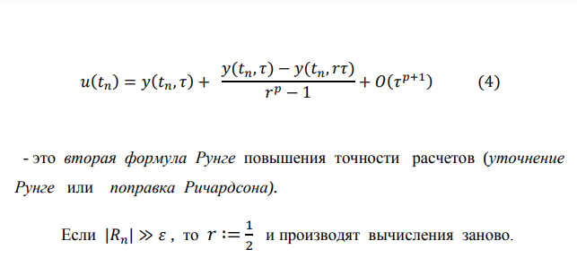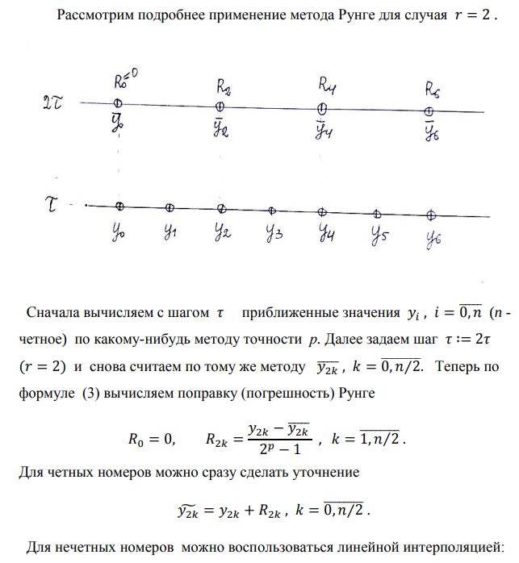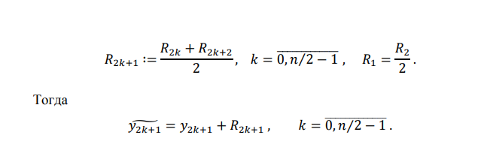

h2 = 0.2

r = h2/h1

p = 2

y2 = [0 for i in range(n)]

R = [0.0 for i in range(n)]

y2[0] = 0.541325

for i in range(0, n-2, 2):

y2[i+2] = y1[i] + h2/2\*(df(x[i+2],y[i+2]) + df(x[i],y[i]))

for i in range(2, n, 2):

R[i] = (y1[i]-y2[i])/(math.pow(r, p) - 1)

y2[i] = y1[i] + R[i]

for i in range(1,n,2):

R[i] = (R[i+1] + R[i-1])/2

y2[i] = y1[i] + R[i]

